
ENTRUST YOUR WINES TO A SPECIALIST
Reference: CBU7S1B
Eno temperaturno področje
Built-under counter range

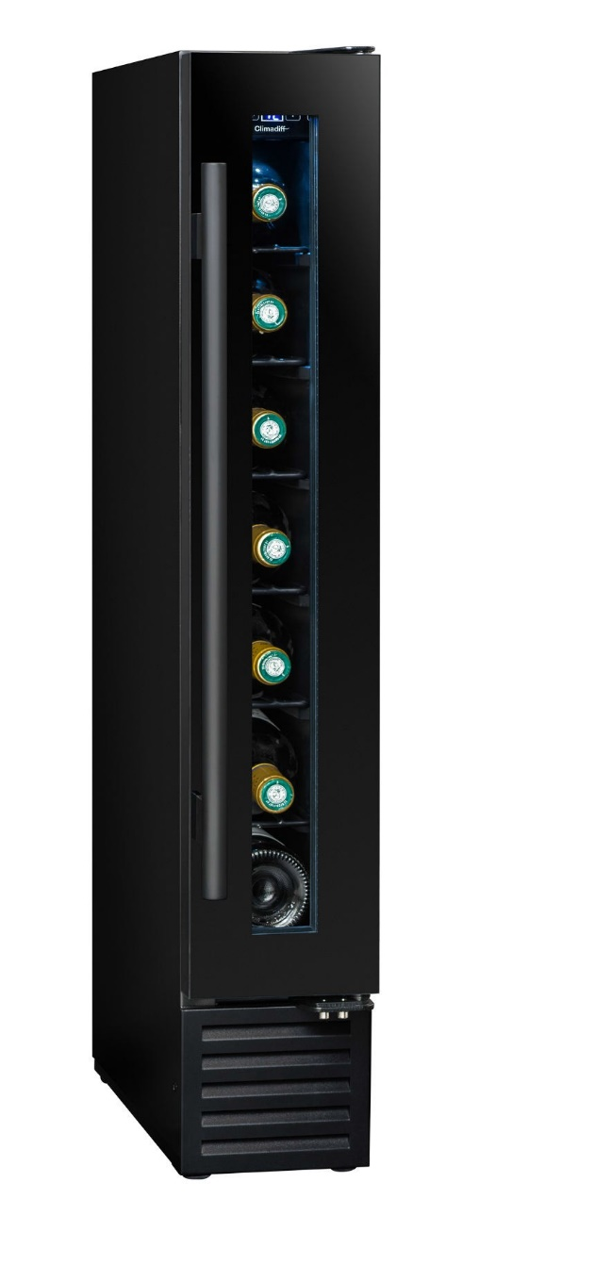

Kapaciteta: 7 steklenic*
Podpultno vgradna
Design: black body & black piano organic glass door frame
Hladilni sistem: kompresor
Vrsta hlajenja: zračni sistem
Nastavljivo temp. področje: 5-20°C
Elektronsko upravljanje
Termometer z modro osvetlitvijo
Bele LED luči z možnostjo izklopa
1 zamenljiva vrata, 2-slojno kaljeno steklo (transparent)


Our products are manufactured in compliance with European environmental rules. Especially, refrigerant fluid (R600a) doesn’t reject neither CFC nor HFC and respect environment.

Energy consumption is calculated based on the result obtained for 24h in standard test conditions. The actual energy consumption depends on the conditions of use and location of the device.
This equipment is designed to be used in an ambient temperature between 10-38°C.
This appliance is intended to be used exclusively for the storage of wine. Alcohol abuse is dangerous for health, please consume in moderation.
*Capacity given as an indication with 75cl Bordeaux traditional type bottles and measured with 6 shelves. Adding shelves reduce considerably the total capacity.

ENTRUST YOUR WINES TO A SPECIALIST
Reference: CBU7S1B
Eno temperaturno področje
Built-under counter range

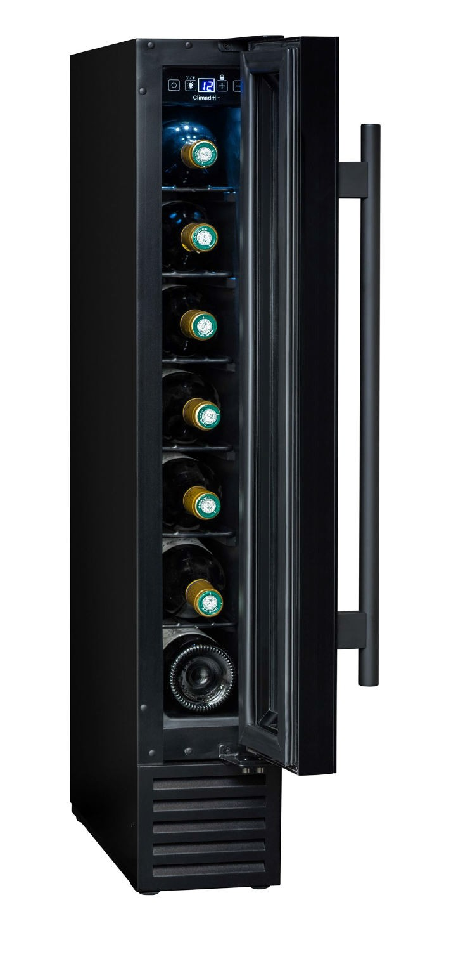

> LOGISTIC DATAS

Bruto dimenzije (ŠxGxV cm) : 18 x 52 x 90
Neto dimenzije (ŠxGxV cm) : 14,5 x 47,5 x 86,5 Bruto teža (kg) : 22.50
Neto teža (kg) : 20.50

EAN 3595320106367
> VKLJUČENA OPREMA

6 kovinskih polic
4 nastavljive nogice (V. 7.5 cm) Anti-vibration sistem

> TEHNIČNI PODATKI

Energijski razred: G
Letna poraba energije: 98 kWh
Klimatski razred: SN-ST
Glasnost: 44 dB
Napetost: 220-240 V Moč: 50 W
Category: 2 - Wine cellar Vrsta plina: R600a

> VARNOST

Anti-freeze security: ensures a positive temperature in your cellar and prevents the freezing of your bottles in winter
Child lock: locks the control panel

> COMPATIBLE ACCESSORIES

Only available in spare parts

